35.43: At points on the same side of the centerline as point 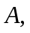the path from  is longer than the path from and the path difference sin puts speaker  ahead of speaker in phase. Constructive interference occurs when
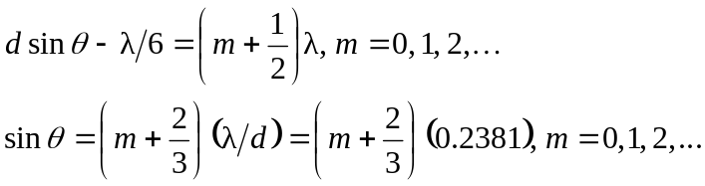
no solution
At points on the other side of the centerline, the path from is longer than the path from , and the path difference d sin puts speaker behind speaker in phase. Constructive interference occurs when
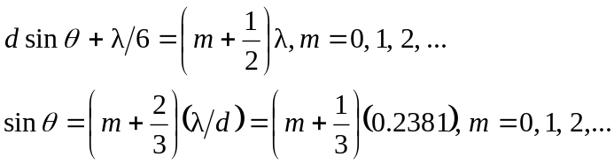
no solution

